**Crime Statistics Report (Bangladesh, 2020-2025)**

# Introduction

# Crime statistics play a crucial role in understanding the law and order situation of a country. Analyzing crime trends over time allows law enforcement agencies, policymakers, and researchers to make informed decisions, allocate resources effectively, and implement strategic crime prevention measures.

# This report presents a comprehensive analysis of crime statistics in Bangladesh from 2020 to 2025, covering a range of key crime categories, regional crime rates, and yearly trends. The dataset includes crimes such as dacoity, robbery, murder, narcotics-related offenses, smuggling, and crimes against women & children, among others.

# Objectives of the Report

# ✔ Identify overall crime trends over the years, including fluctuations and major spikes.

# ✔ Analyze crime distribution by category, highlighting the most prevalent offenses.

# ✔ Examine regional crime rates to determine which areas experience the highest crime levels.

# ✔ Evaluate yearly crime trends and percentage changes to assess improvements or deteriorations in law enforcement efforts.

# ✔ Investigate recovery cases related to arms, explosives, narcotics, and smuggling.

# ✔ Provide SQL queries used in the analysis, ensuring transparency and reproducibility.

# This report includes detailed visualizations, statistical insights, and structured tables to make the findings easily interpretable. The findings in this report can serve as a foundation for further investigations and policy decisions aimed at improving public safety in Bangladesh.

# Key Performance Indicators (KPIs)

* Total Reported Cases: 996,839
* Total Recovery Cases: 405,665
* Average Cases Per Month: 16,078.05

**SQL Query:**

SELECT

    SUM(total_cases) AS total_cases,

    SUM(arms_act) + SUM(explosive) + SUM(narcotics) + SUM(smuggling) AS total_recovery_cases,

    SUM(total_cases) / COUNT(DISTINCT CONCAT(month, ' ', year)) AS avg_cases_per_month

FROM crime_statistics;

**Monthly Crime Trends**

This line graph illustrates the fluctuations in reported crimes on a monthly basis. There are noticeable spikes at certain months, indicating seasonal variations or specific events contributing to crime surges.

Highest Crime Months:

* July 2022 recorded the highest number of cases (~20,300 cases).
* August 2022 also had a high surge (~19,800 cases).

Lowest Crime Months:

* April 2025 had the lowest reported cases (~4,200 cases).
* March 2025 followed closely (~4,500 cases).

Overall Trends:

* Crime rates peaked in mid-2022, possibly due to economic or social unrest.
* Steady decline from late 2023 onward, with a sharp drop in 2025.

**SQL Query:**

SELECT

        CONCAT(month, ' ', year) AS month_year,

    SUM(total_cases) AS total_cases_per_month

    FROM crime_statistics

GROUP BY month, year

ORDER BY year, EXTRACT(MONTH FROM TO_DATE(month, 'Month'));

**Crime Distribution by Type**

The bar chart above represents the total cases reported for each crime category. 'Other Cases' and 'Narcotics' make up the largest share of reported crimes, indicating a high focus on drug-related offenses.

Top 3 Most Reported Crimes:

* Other Cases – 376,996 cases (37.8% of total crimes)
* Narcotics – 354,253 cases (35.5%)
* Crimes Against Women & Children – 103,061 cases (10.3%)

Lesser Reported Crimes:

* Dacoity (24,250 cases) and Robbery (6,048 cases) were among the lowest.
* Explosives-related crimes (15,912 cases) showed an unusual increase in 2022 and 2023.

Key Takeaways:

* Drug-related crimes (Narcotics & Smuggling) dominate the crime landscape.
* Violence against women & children remains a major concern.
* Theft & Burglary make up a significant portion of property-related crimes.

**SQL Query:**

WITH Total_Cases AS (

    SELECT SUM(dacoity) + SUM(robbery) + SUM(murder) + SUM(speedy_trial) +

           SUM(riot) + SUM(woman_child_repression) + SUM(kidnapping) +

           SUM(police_assault) + SUM(burglary) + SUM(theft) +

           SUM(other_cases) + SUM(arms_act) + SUM(explosive) +

           SUM(narcotics) + SUM(smuggling) AS grand_total

    FROM crime_statistics

)

SELECT

    'Dacoity' AS crime_type,

    SUM(dacoity) AS total_cases,

    (SUM(dacoity) * 100.0 / (SELECT grand_total FROM Total_Cases))::NUMERIC(5,2) AS percentage

FROM crime_statistics

UNION ALL

SELECT

    'Robbery',

    SUM(robbery),

    (SUM(robbery) * 100.0 / (SELECT grand_total FROM Total_Cases))::NUMERIC(5,2)

FROM crime_statistics

UNION ALL

SELECT

    'Murder',

    SUM(murder),

    (SUM(murder) * 100.0 / (SELECT grand_total FROM Total_Cases))::NUMERIC(5,2)

FROM crime_statistics

UNION ALL

SELECT

    'Speedy Trial',

    SUM(speedy_trial),

    (SUM(speedy_trial) * 100.0 / (SELECT grand_total FROM Total_Cases))::NUMERIC(5,2)

FROM crime_statistics

UNION ALL

SELECT

    'Riot',

    SUM(riot),

    (SUM(riot) * 100.0 / (SELECT grand_total FROM Total_Cases))::NUMERIC(5,2)

FROM crime_statistics

UNION ALL

SELECT

    'Woman & Child Repression',

    SUM(woman_child_repression),

    (SUM(woman_child_repression) * 100.0 / (SELECT grand_total FROM Total_Cases))::NUMERIC(5,2)

FROM crime_statistics

UNION ALL

SELECT

    'Kidnapping',

    SUM(kidnapping),

    (SUM(kidnapping) * 100.0 / (SELECT grand_total FROM Total_Cases))::NUMERIC(5,2)

FROM crime_statistics

UNION ALL

SELECT

    'Police Assault',

    SUM(police_assault),

    (SUM(police_assault) * 100.0 / (SELECT grand_total FROM Total_Cases))::NUMERIC(5,2)

FROM crime_statistics

UNION ALL

SELECT

    'Burglary',

    SUM(burglary),

    (SUM(burglary) * 100.0 / (SELECT grand_total FROM Total_Cases))::NUMERIC(5,2)

FROM crime_statistics

UNION ALL

SELECT

    'Theft',

    SUM(theft),

    (SUM(theft) * 100.0 / (SELECT grand_total FROM Total_Cases))::NUMERIC(5,2)

FROM crime_statistics

UNION ALL

SELECT

    'Other Cases',

    SUM(other_cases),

    (SUM(other_cases) * 100.0 / (SELECT grand_total FROM Total_Cases))::NUMERIC(5,2)

FROM crime_statistics

UNION ALL

SELECT

    'Arms Act',

    SUM(arms_act),

    (SUM(arms_act) * 100.0 / (SELECT grand_total FROM Total_Cases))::NUMERIC(5,2)

FROM crime_statistics

UNION ALL

SELECT

    'Explosive',

    SUM(explosive),

    (SUM(explosive) * 100.0 / (SELECT grand_total FROM Total_Cases))::NUMERIC(5,2)

FROM crime_statistics

UNION ALL

SELECT

    'Narcotics',

    SUM(narcotics),

    (SUM(narcotics) * 100.0 / (SELECT grand_total FROM Total_Cases))::NUMERIC(5,2)

FROM crime_statistics

UNION ALL

SELECT

    'Smuggling',

    SUM(smuggling),

    (SUM(smuggling) * 100.0 / (SELECT grand_total FROM Total_Cases))::NUMERIC(5,2)

FROM crime_statistics

ORDER BY total_cases DESC;

# Yearly Crime Trends

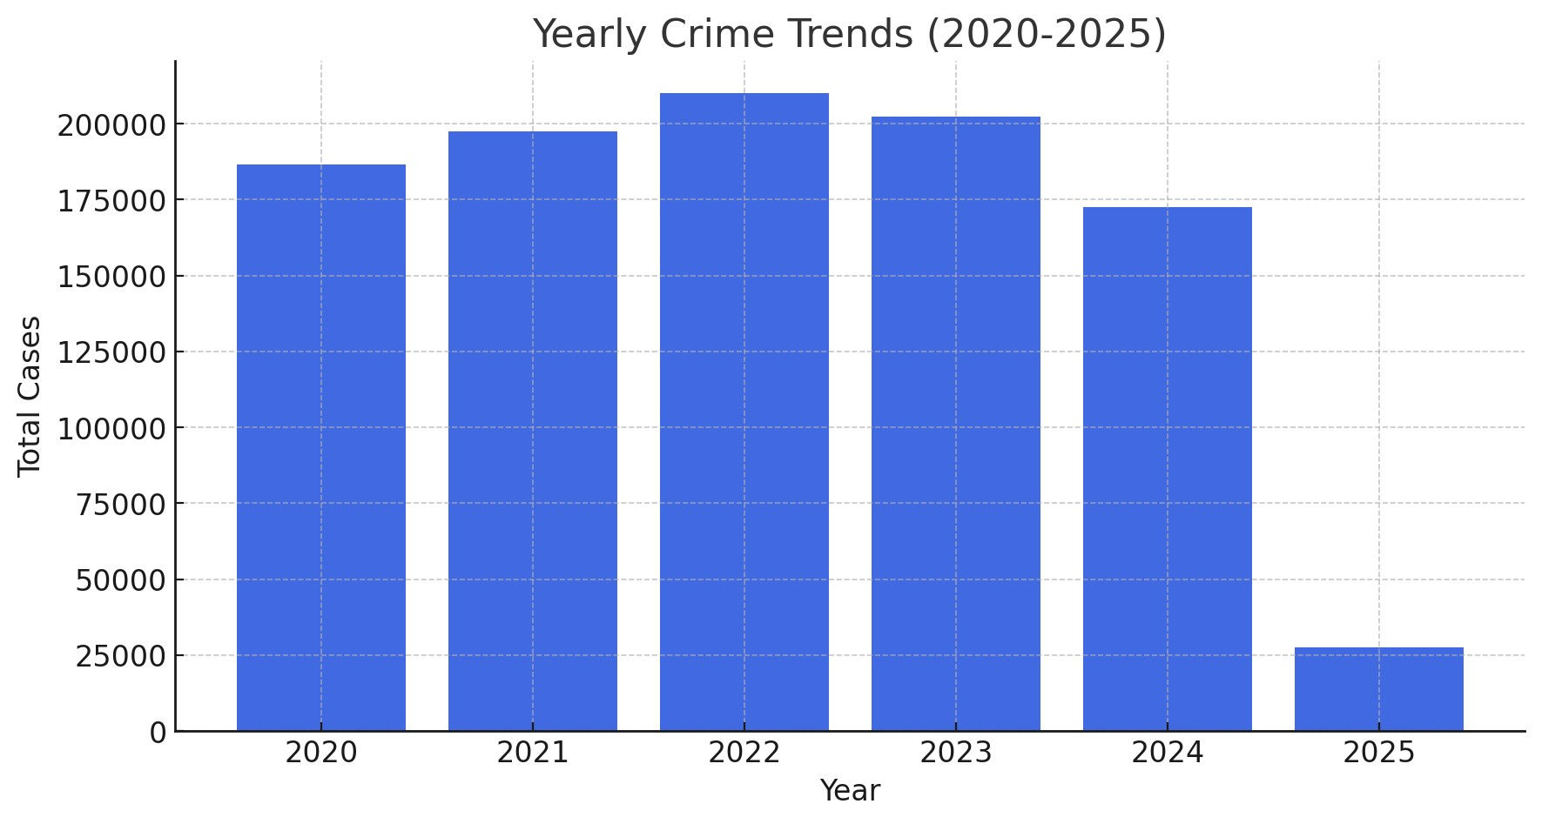

The bar chart above shows the total reported crimes each year from 2020 to 2025. Crime rates peaked in 2022 but began declining in 2023, with a significant drop in 2024 and 2025. The sharp decline in 2025 suggests incomplete data or improved law enforcement measures.

**Yearly Crime Trends:**

* 2020: 186,565 cases
* 2021: 197,564 cases (5.90% change)
* 2022: 210,136 cases (6.36% change)
* 2023: 202,489 cases (-3.64% change)
* 2024: 172,511 cases (-14.80% change)
* 2025: 27,574 cases (-84.02% change

**SQL Query:**

WITH Yearly_Crime AS (

    SELECT

        Year,

        SUM(total_cases) AS total_crimes,

        SUM(total_cases) / COUNT(DISTINCT CONCAT(month, ' ', year)) AS crime_rate

    FROM Crime_Statistics

    GROUP BY Year

)

SELECT

    Year,

    crime_rate,

    LAG(crime_rate) OVER (ORDER BY Year) AS PY_Crime_rate,

    CAST(

        (crime_rate - LAG(crime_rate) OVER (ORDER BY Year)) * 100.0 /

        NULLIF(LAG(crime_rate) OVER (ORDER BY Year), 0)

        AS NUMERIC(5,2)

    ) AS Percentage_Change

FROM Yearly_Crime

ORDER BY Year;

# Top Crime-Prone Units

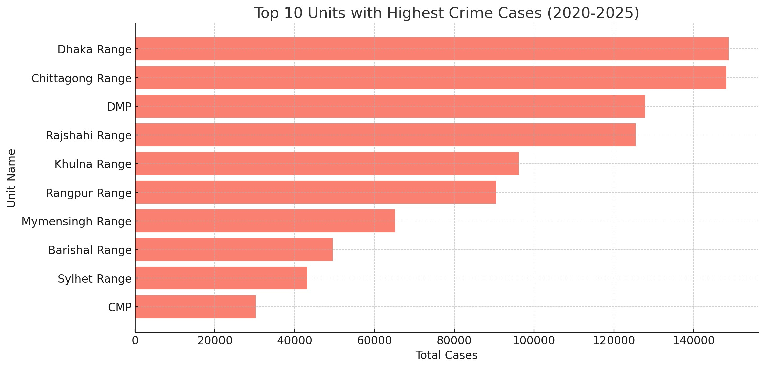

This chart highlights the top 10 regions with the highest reported crime cases. Dhaka Range and Chittagong Range have the highest crime rates, with Dhaka Metropolitan Police (DMP) also reporting significantly high numbers

* Dhaka Range: 148,792 cases (Avg 2400/month)
* Chittagong Range: 148,206 cases (Avg 2390/month)
* DMP: 127,810 cases (Avg 2061/month)
* Rajshahi Range: 125,444 cases (Avg 2023/month)
* Khulna Range: 96,156 cases (Avg 1551/month)

# Yearly Rates of the Most Discussed Crimes

This graph displays the average monthly cases of the most discussed crimes (Kidnapping, Burglary, Theft, Dacoity, Robbery, and Crimes Against Women & Children). Theft cases saw a sharp rise in 2022 and 2023, while crimes against women & children show a consistent downward trend.

Theft Cases:

* Peaked in 2023 with 1,245 cases/month.
* Declined in 2024 to 770 cases/month.

Dacoity & Robbery Cases:

* Dacoity cases increased sharply in 2025, reaching 72 cases/month.
* Robbery followed a similar trend, hitting 162 cases/month in 2025.

Kidnapping & Burglary Cases:

* Kidnapping cases steadily increased from 42/month (2023) to 91/month (2025).
* Burglary cases remained stable at around 220-250 cases/month.

Women & Child Repression:

* Consistent decline from 1,935 cases/month in 2020 to 1,435 cases/month in 2025.
* Significant drop between 2022 and 2023, suggesting improved law enforcement efforts.

**SQL Query:**

SELECT

    crime_type,

    COALESCE(ROUND(AVG(CASE WHEN year = 2020 THEN total_cases END), 0), 0) AS "2020",

    COALESCE(ROUND(AVG(CASE WHEN year = 2021 THEN total_cases END), 0), 0) AS "2021",

    COALESCE(ROUND(AVG(CASE WHEN year = 2022 THEN total_cases END), 0), 0) AS "2022",

    COALESCE(ROUND(AVG(CASE WHEN year = 2023 THEN total_cases END), 0), 0) AS "2023",

    COALESCE(ROUND(AVG(CASE WHEN year = 2024 THEN total_cases END), 0), 0) AS "2024",

    COALESCE(ROUND(AVG(CASE WHEN year = 2025 THEN total_cases END), 0), 0) AS "2025"

FROM (

    SELECT

        year, 'Kidnapping' AS crime_type, SUM(kidnapping) / COUNT(DISTINCT month) AS total_cases FROM crime_statistics GROUP BY year

    UNION ALL

    SELECT

        year, 'Burglary', SUM(burglary) / COUNT(DISTINCT month) FROM crime_statistics GROUP BY year

    UNION ALL

    SELECT

        year, 'Theft', SUM(theft) / COUNT(DISTINCT month) FROM crime_statistics GROUP BY year

    UNION ALL

    SELECT

        year, 'Dacoity', SUM(dacoity) / COUNT(DISTINCT month) FROM crime_statistics GROUP BY year

    UNION ALL

    SELECT

        year, 'Robbery', SUM(robbery) / COUNT(DISTINCT month) FROM crime_statistics GROUP BY year

    UNION ALL

    SELECT

        year, 'Woman & Child Repression', SUM(woman_child_repression) / COUNT(DISTINCT month) FROM crime_statistics GROUP BY year

) AS CrimeData

GROUP BY crime_type

ORDER BY crime_type;

# Recovery Crime Trends

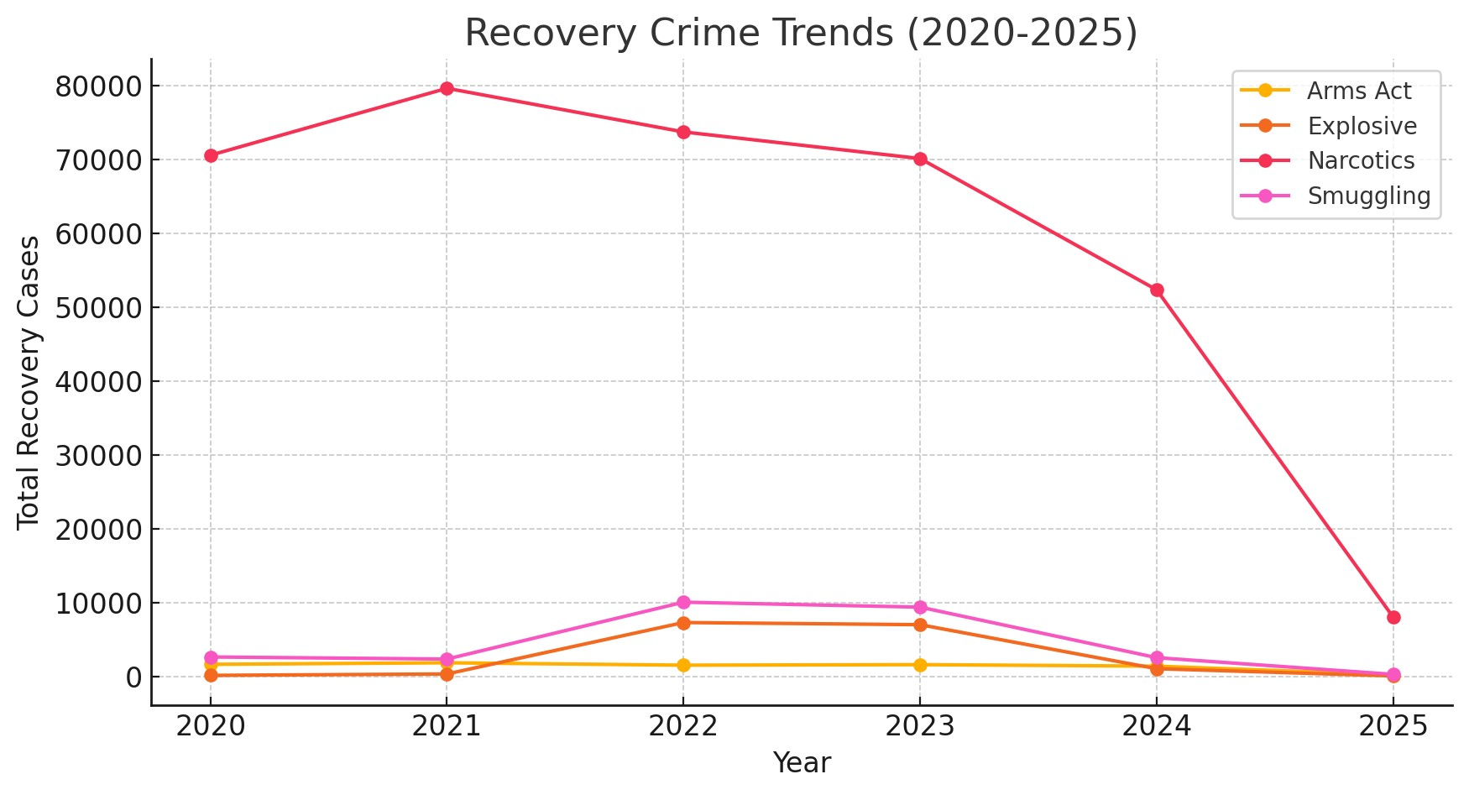

This line chart presents the trends in crime recoveries (Arms Act, Explosives, Narcotics, and Smuggling). Narcotics recovery cases are the highest, with notable peaks in 2021 and 2022. Smuggling cases had a temporary surge in 2022

* 2020: Narcotics 70,540, Smuggling 2,638, Explosives 148, Arms Act 1,643
* 2021: Narcotics 79,596, Smuggling 2,354, Explosives 338, Arms Act 1,853
* 2022: Narcotics 73,690, Smuggling 10,053, Explosives 7,300, Arms Act 1,525
* 2023: Narcotics 70,088, Smuggling 9,382, Explosives 7,005, Arms Act 1,600
* 2024: Narcotics 52,321, Smuggling 2,543, Explosives 1,049, Arms Act 1,394

**SQL Query:**

WITH Crime_Totals AS (

    SELECT

        'Arms Act' AS crime_type, SUM(arms_act) AS total_cases FROM crime_statistics

    UNION ALL

    SELECT

        'Explosive', SUM(explosive) FROM crime_statistics

    UNION ALL

    SELECT

        'Narcotics', SUM(narcotics) FROM crime_statistics

    UNION ALL

    SELECT

        'Smuggling', SUM(smuggling) FROM crime_statistics

),

Total_Crimes AS (

    SELECT SUM(total_cases) AS overall_total FROM Crime_Totals

)

SELECT

    ct.crime_type,

    ct.total_cases,

    ROUND((ct.total_cases * 100.0) / NULLIF(tc.overall_total, 0), 2) AS crime_percentage

FROM Crime_Totals ct

JOIN Total_Crimes tc ON 1=1

ORDER BY ct.total_cases DESC;

**Conclusion**

This report provides a comprehensive analysis of crime trends in Bangladesh from 2020 to 2025, offering key insights into crime distribution, regional crime rates, and yearly trends.

Key Takeaways:

* Total crime cases peaked in 2022, followed by a steady decline in 2023 and beyond.
* Drug-related crimes (Narcotics & Smuggling) dominate, making up over 35% of total cases.
* Theft and Burglary remain significant property crimes, with Theft cases peaking in 2023.
* Crimes Against Women & Children have shown a downward trend, indicating potential improvements in law enforcement.
* Regional analysis shows Dhaka & Chittagong as the most crime-prone areas, demanding focused intervention.

Understanding these crime trends is essential for policy formulation, law enforcement planning, and public safety initiatives. By leveraging data-driven insights, authorities can implement targeted crime prevention strategies and improve public security across Bangladesh.